# CS 255 System Design Document Template

Eric Breznen

This template lays out all the different sections that you need to complete for Project Two. Each section has guidance to prompt your thinking. You will need to continually reference the interview transcript as you work to make sure that you are addressing your client’s needs. There is no required length for the final document. Instead the goal is to complete each section based on what your client’s needs are. Remove this note when you are finished, and replace all bracketed text with the relevant information.

## UML Diagrams

### UML Use Case Diagram

### UML Activity Diagrams

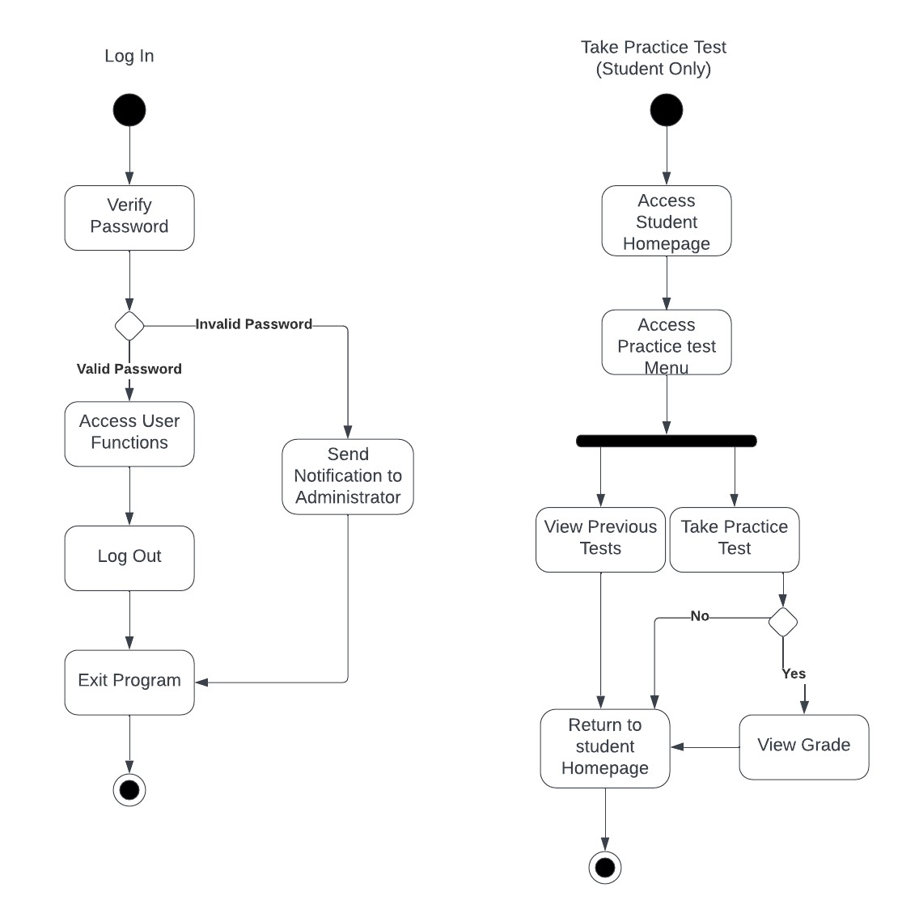

### UML Class Diagram

## Technical Requirements

* The system requires a cloud-based web architecture that can run on multiple client operating systems.
* The system requires a stable internet connection and the hardware (routers, modems, etc.) that supports this.
* The system requires connection to multiple living databases (schedule, user activity tracker, student information, employee information, vehicle tracker).
* The system also requires every user to have a PC along with monitors, mice, and keyboards as well as phones and printers for employees.